***Term Project***

**Online Cloth Recycling Service**

*Aditi Namdeo*

*Namdeo.a@northeastern.edu*

*617-606-8316*

Submission Date: 7/8/2023

EMGT5220: Engineering Project Management, Fall 2021

Northeastern University

Instructor: Prof. George Kontopidis

Table of Contents

1. Purpose 3

2. Objective 3

3. Scope 3

4. Funding Plan 3

7. Technical Approach 4

8. Organization 4

9. Project Plan 5

a. Work Breakdown Structure (WBS) 6

b. RACI Matrix……………………………………………………………………………………………...7

c. Financial Plan 8

d. PERT Table and Chart 8

e. Gantt and Resource Loading Charts 9

10. Risk Assessment (SWOT, FMEA, RPN) 10

11. Conclusion 12

12. Appendix 12

a. Mind Map 12

13. References 13

**Revision History**

|  |  |
| --- | --- |
| 7/8/2023 | Draft #1 |
| 7/17/2023 | Draft #2 |
| 7/31/2023 | Draft #3 |
| 8/9/2023 | Final Project Report |

## Purpose

People tend to have more clothes than they need and are more indulgent in the process of buying more clothes than ever considering an appropriate way to get rid of their existing unworthy, non-trendy, excessive or simply outgrown clothes.

This leads to every house and individual having extra clothes that can be recycled/upcycled or donated to the needful. But there is not an existing simple & reliable way that makes this process easy and which can be done from home. The purpose of this project is to solve this problem.

## Objective

This project aims to build a web/app service that will be a portal to recycling/upcycling or donating any extra clothing which the user has. There are existent slow, local and unreliable ways that try to solve this problem but aren’t successful in solving the problem at a larger global scale along with maintaining the trust factor. The project aims to deliver this service globally and make it 100% transparent to the user how their clothing is being of use to the needful or being upcycled/recycled for better usage.

The recipient of the project is essentially is an individual user. The user won’t be paying any fee for this service, the purpose of which is to align with the idea of recycling/ upcycling and donating clothing where necessary for goodwill and sustainability. This will also boost user counts to a higher degree.

## Scope

The scope of this project is to create an online service primarily a website which will offer options like recycling, upcycling and donation options to the user. The clothes will then be reverse supply chained to recycling stations, or upcycling warehouses.

If the user chooses to donate, a preferable charity purpose can be chosen to the likes of the user and the clothes will then be delivered to that particular chosen donation drive. This reverse supply chain will be done by an external service which will be on contract, like DHL, UPS or USPS. We will also create an android/ iPhone application that would be the counterpart of the web service. The user can also choose a subscription model which will collect the extra clothes in regular time intervals as preferred by them.

## Funding Plan

The funder for this project will be a venture capital firm or angel investor looking to make a seed investment in an early-stage online service company. In the initial stages, the venture capitalist or the angel investor will be interested in getting their investment back multiplied. In the further stages they will be interested in higher returns when the company has scaled sufficiently.

Specifically, the clothing industry brands would use our clothes to produce their sustainable line of clothes. Clothing brands, to support sustainable and green initiatives do not use any products which would harm the environment, our project will deliver such clothes to them in return for payment. Apart from this the government would be interested in funding this initiative as part of solving a sustainability issue. Apart from this the project will get major endorsements from celebrities or influential people to support the green initiative.

## Critical Success Factors

The PM will create a list of internal project critical success factors which are paramount to successful project planning, project execution, and project monitoring & control. The project risks substantial scope and financial losses if the below factors are not adhered to. The service will also have to answer to the VC and the CEO as the PM. Comprehensive critical success factors are required to guard against potential project weaknesses.

It is critical that:

* The service’s technical developments are smooth functioning before deployment of website and smartphone application
* The supply chain management has been finalized and tested with dry runs before final deployment for customer usage
* The brand collaborations are proactively taken care of by management along with relationship management
* It is ensured that the technology is tried and tested along with supply chain system in terms of dry run before deployment to minimize any errors in actual deployment phase. A technologically sound and specialized consultant can be hired to suggest more changes or advancements in system.
* Communication is smooth with supply chain vendor on proper guidance for quality check integrations and train personnel in quality control with the accurate steps to be followed.
* A proprietary system coherent with the three parts of the online service is developed and deployment of custom based code and software parts aiding to smooth integration are generated rather than standard technical parts of code being used.

## Assumptions

The PM will create a list of assumptions which identity forces outside of project control. Assumptions are external known-unknowns which allow the PM to prepare for potential project threats. It is more challenging to control assumption consequences than critical success factor outcomes.

It is assumed that:

* Adequate recycling stations are available within regular geographical distances
* Adequate recycling stations have collaborated with the online cloth recycling service to the advancement of their station and profits of the service
* Global restriction is flattened out with technical advancements in lieu of solving sustainable issue
* User subscription model innovation will cater to financial profits and more user generation and user retention based on the smooth functioning of initial service model
* Companies are highly interested in reducing their carbon footprints by collaborating with this eco-friendly initiative

## Technical Approach

The project aims to build an online platform which will primarily be a website hosted globally which will intake the users’ needs and location where the clothing will be picked up from. There will be an android/ iPhone application which does the same. Both of these applications, web + smartphone, are to be made using programming languages for fronted and backend development over cloud along with hosting requirements. The reverse supply chain system is to be maintained in contract with a supply chain service like DHL, USPS or UPS. The project creation requires these following 3 parts for functioning:

1. Website linked with the supply chain service
2. Smart Phone Application as the counterpart of the website
3. Supply chain service integrated with the website/ smart phone application

## Organization

Online Cloth Recycling service is a sustainability initiative startup with an open-ended approach toward the growth of the startup. Since its growing and hasn’t reached its chasm point, being an early growth startup, the organization structure is prioritized towards functionality but with coexistence of projectized departments. The organization structure that is being followed is composite organization structure.

Figure 1 conveys the composite organization chart:

***Figure 1: Organization Chart***

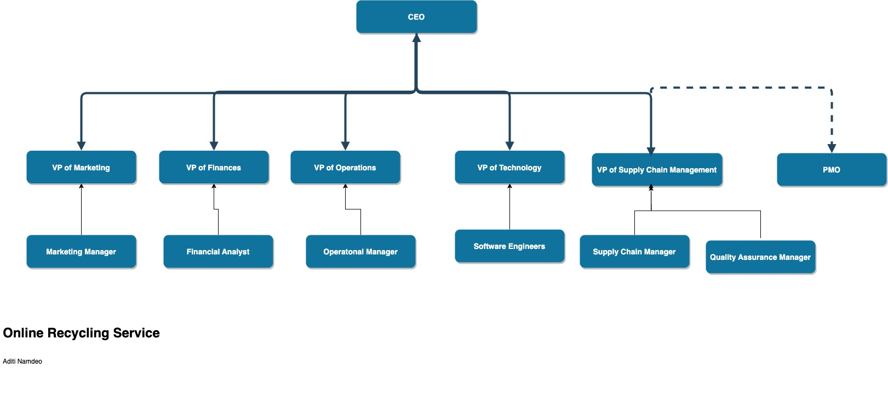

***Org Chart Description***

* The Chief Executive Officer (CEO) acts as the overall project leader of the startup. She is equivalent to be the product owner including the functional aspects of the company; and for these reasons she is also not a part of the project team
* The other functional Vice Presidents- VP of technology, VP of marketing, VP of supply chain operations are leading the functional parts of the startup
* The VP of operations is regarded as an executive position where in he/she is responsible for business collaborations, stakeholder management, involved in key communication with finances etc.
* The web/app service deployment team consists of the functional team

The reporting structure in the company looks like this following figure 2 here. The structure defines employees “working for” hierarchies with supervisors.

***Figure 2: Project Team Reporting Structure***

|  |  |  |  |
| --- | --- | --- | --- |
| Name | Role | Reports | Number of Reports |
| Aby | VP of Finance | Aditi | 1 |
| Aditi | CEO | N/A | 5 |
| Randall | VP of Operations | Aditi | 1 |
| Kylie | VP of Marketing | Aditi | 0 |
| Rob | VP of Supply Chain Operations | Aditi | 1 |
| Jack | VP of  Technology | Aditi | 3 |

The high-level VPs both functional and projectized are set to be independent leaders of their teams. The teams have 1-2 subordinates under the lead VP.

## Project Plan

### Work Breakdown Structure (WBS)

The WBS of the project is detailed in Figure 3 here. The table lists the different tasks in the company, the person responsible for the task, and the duration allotted to accomplish that task. The duration is in days.

***Figure 3: WBS of Online Cloth Recycling Service***

|  |  |  |  |  |  |
| --- | --- | --- | --- | --- | --- |
| ID | Task | Responsibility | No. of People Per Task | Duration (days) | Dependencies |
| 1 | Developing the website | Jack | 2 | 120 | - |
| 1.a | Developing the frontend | Ranbir | 1 | 60 | - |
| 1.b | Developing the backend | Ranbir | 1 | 60 | - |
| 2. | Developing the bootstrapped smartphone application | Jack | 2 | 90 | 1 |
| 2.a | iOS development | Ranbir | 1 | 45 | 1, 1b |
| 2.b | Android development | Ranbir | 1 | 45 | 1, 1b |
| 3. | Signing an official deal with the third-party supply chain vendor | Rob |  | 30 | - |
|  | Hosting the website | Jack | 1 | 10 | 1, 1a, 1b |
|  | Hosting the smartphone applications for iOS + android | Jack | 1 | 15 | 2a, 2b |
| *** | MILESTONE: ALL TECHNOLOGY DEVELOPMENTS ARE MADE AND SERVICE HAS BEEN HOSTED + THIRD PARTY SUPPLY CHAIN DEAL HAS BEEN SMOOTHENED | *** |  | *** | *** |
|  | Quality checks to check app/site smoothness | Kylie | 1 | 30 | 5 |

***WBS Notes***

1. The project is scheduled to accomplish its tasks within 295 days if everything goes according to plan.
2. A ‘work week’ is five days. Weekends are excluded from the WBS.
3. Website development tasks of developing the fronted and the backend run non-concurrently to one another and finish one after the other.
4. Bootstrapped smartphone applications will also be created one after the after since only one software development engineer will be working on both iOS and android.
5. Rob will handle the supply chain management single handedly with 1 supply chain SME employee under him.
6. The development team lead by Jack will host the website and smartphone applications one after the other during the same month and marketing will follow along.
7. After the milestone of technology development and integration with the third-party supply chain management is accomplished, marketing will initiate its campaigns to garner maximum users.

Figure 4 represents the project’s RACI Matrix. The RACI matrix assigns project team members to categories of ‘responsible’, ‘accountable’, ‘consulted’, and ‘informed’ parties. WBS tasks directly aligns with the ‘responsible’ parties.

### RACI Matrix

***Figure 4: RACI Matrix***

|  |  |  |  |  |
| --- | --- | --- | --- | --- |
| **WBS ID** | **Responsible** | **Accountable** | **Consulted** | **Informed** |
| **1** | Jack | Jack | Rob, Aditi, Kylie, Aby | CEO, VP of Finance |
| **1.a** | Ranbir | Jack | Rob, Aditi, Kylie | CEO, VP of Finance |
| **1.b** | Ranbir | Jack | Rob, Aditi | CEO, VP of Finance |
| **2** | Jack | Jack | Rob, Aditi, Kylie, Aby | CEO, VP of Finance |
| **2.a** | Ranbir | Jack | Rob, Aditi, Kylie | CEO, VP of Finance |
| **2.b** | Ranbir | Jack | Rob, Aditi, Kylie | CEO, VP of Finance |
| **3** | Rob | Rob | Aditi, Aby | CEO, VP of Finance, VP of Operations |
| **4** | Jack | Jack | Aditi, Aby | CEO, VP of Finance |
| **5** | Jack | Jack | Aditi, Aby | CEO, VP of Finance |
| **6** | Kylie | Kylie | Aditi, Aby, Randall | CEO, VP of Finance, VP of Operations |

### Financial Plan

This monthly financial plan for the project is derived from the initial funding from investors of $1 Million. It is inclusive of any and all revenue gained in the 30 days of deployed service which is run for quality check by marketing team and post initial marketing campaigns.

**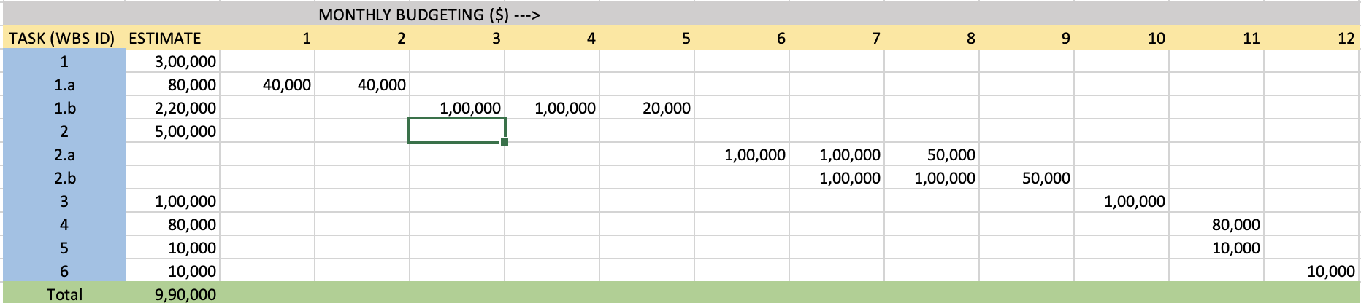*Figure 5: 2023 Monthly Projectized Budget for Online Cloth Recycling Service***

### PERT Table and Chart

The PERT table in Figure 6 lists WBS tasks, the Earliest Start (ES), Earliest Finish (EF), Latest Start (LS) and Latest Finish (LF) dates, including the slack in days.

***Figure 6: PERT Table***

|  |  |  |  |  |  |
| --- | --- | --- | --- | --- | --- |
| WBS Task ID | ES | EF | LS | LF | Slack |
| 1, a-b | 0 | 60 | 80 | 140 | 20 |
| 2, a-b | 60 | 105 | 60 | 105 | 0 |
| 3 | 0 | 30 | 120 | 150 | 90 |
| 4 | 60 | 70 | 140 | 150 | 70 |
| 5 | 105 | 120 | 105 | 120 | 0 |
| 6 | 120 | 150 | 120 | 150 | 0 |

The PERT Chart in Figure 7 includes the task dependencies and depicts the Figure 6 tasks. Figure 7 acts as a springboard for the GANTT Chart in Figure 8. The chart is a general structure of the task flow.

***Figure 7: PERT Chart***

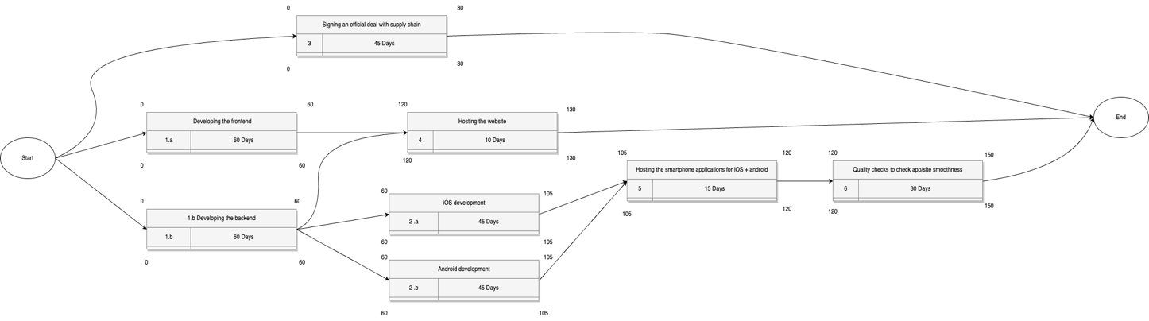

### GANTT Chart

The Figure 8 represents the GANTT Chart for the project. Project team members do not work on weekends. The figure accurately represents a trend, unlike the PERT chart that doesn’t include weekends in its critical path approximation. GANTT Chart is a better representation due to the certain particular factor inclusions in time such as weekend work days.

***Figure 8: GANTT Chart***

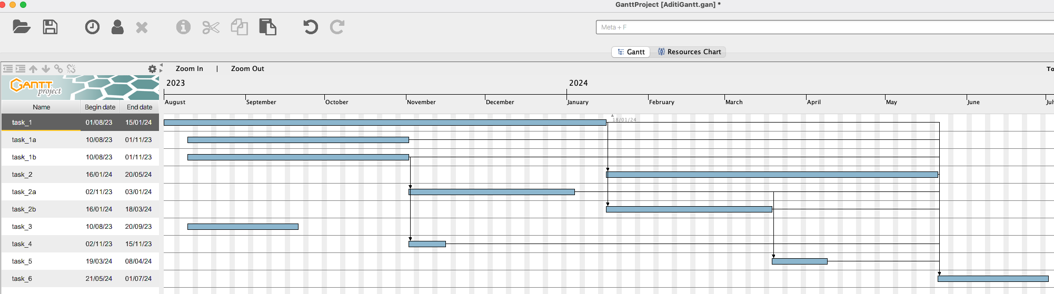

***Figure 9: Resources Chart***

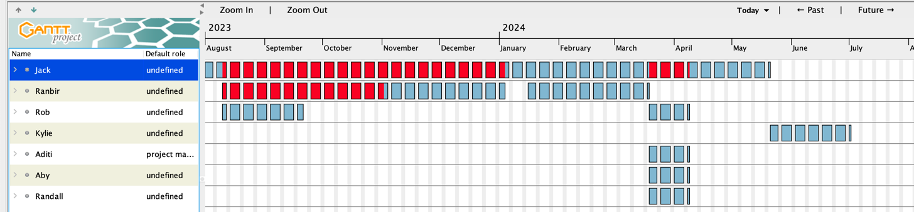

## Risk Assessment (SWOT, FMEA, RPN)

The online service project’s Risk Assessment includes a Strength, Weakness, Opportunity; and Threat (SWOT) Analysis; Risk Priority Number (RPN) breakdown and associated Failure Model & Effects (FMEA) Analysis; and Risk Mitigation Strategies. Critical Success Factors and Assumptions sections explained earlier in the report are related to the four Risk Assessment figures.

***Fig 10. SWOT Analysis***

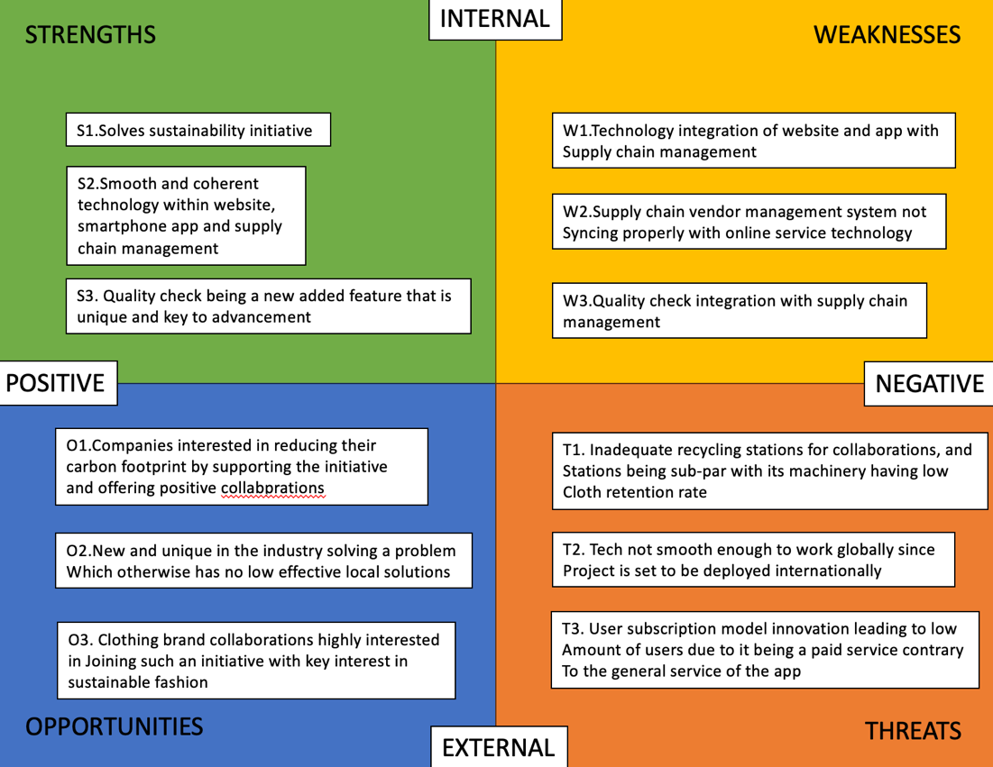

Figure 12 lists project weaknesses and threats in the FMEA matrix according to RPN. Severity (S), likelihood (L), and inability to detect (D) factors are multiplied together to calculate RPN for each weakness or threat. S can also be called impact; L can also be called probability. W3 assumes that W4 is true.

***Figure 11: FMEA Analysis***

|  |  |  |  |  |
| --- | --- | --- | --- | --- |
| **Weakness or Threat** | **S** | **L** | **D** | **RPN** |
| **T2.** Tech not smooth enough to work globally since project is set to be deployed internationally | 7 | 8 | 5 | **3** |
| **W1.** Technology integration of website and app with Supply chain management | 6 | 6 | 3 | **2** |
| **W3.** Quality check integration with supply chain management | 7 | 5 | 2 | **5** |
| **W2.** Supply chain vendor management system not syncing properly with online service technology | 6 | 4 | 3 | **1** |
| **T1.** Inadequate recycling stations for collaborations, and stations being sub-par with its machinery having low  cloth retention rate | 4 | 1 | 4 | **4** |

Figure 13’s Risk Matrix plots weakness and threat severity against likelihood. Risks are categorized as low, medium, or high based upon of the severity (x axis) and likelihood (y-axis) factors. The x and y axes are nine units long; each box is three units long

***Figure 12: Risk Matrix***

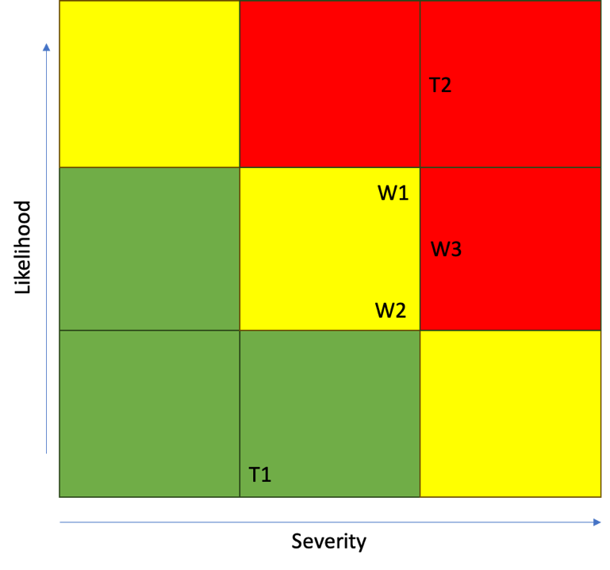

Figure 14 suggests potential mitigation strategies for the three highest RPNs.

***Figure 13: Risk Mitigation Strategies***

|  |  |
| --- | --- |
| **Weakness or Threat** | **Response** |
| **T2.** Tech not smooth enough to work globally since project is set to be deployed internationally | Ensure that the technology is tried and tested along with supply chain system before deployment to minimize any errors in actual deployment phase. Hire a highly skilled technological consultant to suggest more changes or system advancements. |
| **W3.** Quality check integration with supply chain management | Communicate with supply chain vendor on proper guidance for quality check integrations and train personnel in quality control with the accurate steps to be followed |
| **W1.** Technology integration of website and app with Supply chain management | Build proprietary system coherent with the three parts of the service and deploy custom based code and software parts aiding to the task of smooth integration |

## Conclusion

In conclusion of this online service development company, Aditi being the CEO of the company project must meticulously define the project charter and mind map followed by further statements to solidify the project requirements and implementation flow. After creating a realistic and reasonably-attainable scope, schedule, financial plan and well-developed risk assessment and mitigation strategies, the chances of success of the project are increased to a great extent. Aditi will establish the way for technology advancement in the field of everyday improvement towards sustainable development and climate change by solving this common household problem.

Based on the service’s technical requirements and funding plan, management and the VC/angel investor will be the ultimate beneficiaries of project success. Executive personnel of the project will be responsible for leading the company and the VC firm will increase its investment based on that. Aditi is a secondary stakeholder in the scenario in the terms that implementation team members are catering to the needs and managing funds for profitable outcomes for the VC and then secondarily being led by Aditi as she is responsible for overall planning of the process, monitoring the project, and leading to its profitable financial success. She is also the key personnel for innovation and handles all financial flows with the VC. Apart from acting as PMO for the online service company, she is responsible for any and all results or effects to the service.

## Appendix

### Mind Map

The mind map below in Fig. is the precursor to the WBS and defines the task roughly. It is made using an online tool and acts as a guiding path toward any and all tasks in the service company.

***Figure 14: Mind Map***

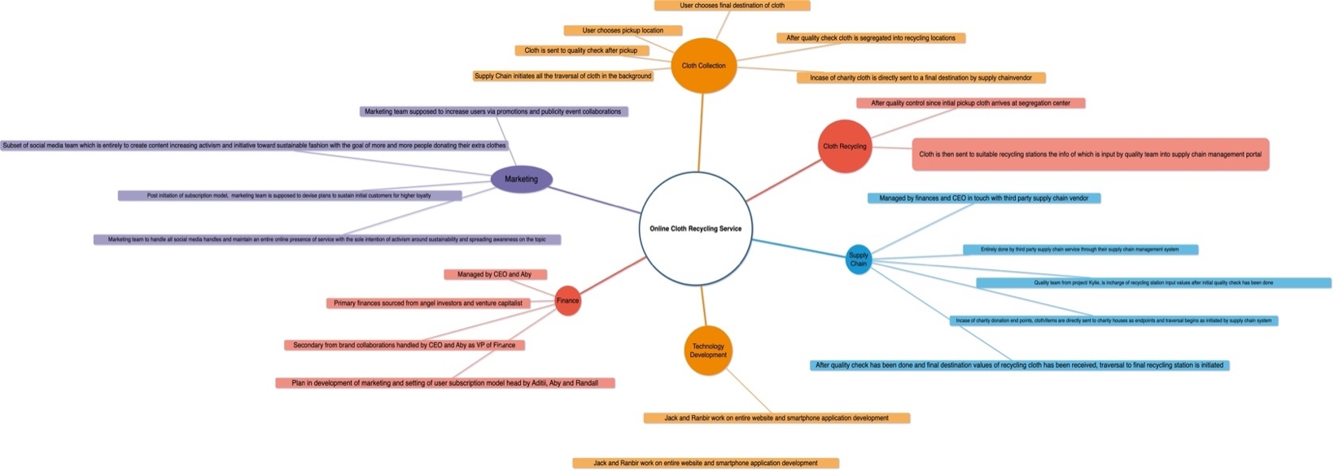

## References

Sites referred-

1. <https://trashwarrior.getdimension.com/junk_removal?dynamic=On%20Demand%20Recycling%20Pickup&gad=1&gclid=CjwKCAjw8symBhAqEiwAaTA__HUnJ4FcZIIDTP4n6WPDIPmnQ0oaNZPwm17zOqp2MuQApeAq7jegkxoC57EQAvD_BwE&location=&market=Boston>
2. <https://www.republicservices.com/>
3. <https://www.protekrecycling.com/contact/boston/>

Kontopidis, Prof. George. *EMGT 5220 Course Slides, Northeastern University.* Summer 02 2023.

Meredith, Jack R., et al. *Project Management: A Strategic Managerial Approach*. Tenth ed., John Wiley & Sons, 2021.